Title of the paper
(Times New Roman, Bold,14 pts, Centered)

First name LAST NAME¹, First name LAST NAME², etc. (Times New Roman,11 pts, Centered)

¹Author address (Times New Roman,10 pts, Centered)
²Author address (Times New Roman,10 pts, Centered)
Email¹, Email², etc. (Times New Roman,10 pts, Italics Centered, Email of the corresponding author in bold)

Abstract: The text of the abstract should be in Times New Roman, 9 pts, justified, single-spaced. The abstract should be a maximum of 1200 characters including spaces and presented in one paragraph. It should concisely reflect the investigated problem or objectives, the methodology, the results, and conclusions of the work.

Keywords: 6 maximum

- Introduction (Times New Roman,12 pts, Bold)
This Section Introduction is mandatory.

- Title of Section 2 (Times New Roman,12 pts, Bold)
Text starts here.

  - Title of Subsection 2 (Times New Roman,10 pts, Bold)
Text starts here.

    - Subtitle of Subsection 2 (Times New Roman,10 pts, Italic)
Text starts here.

    - About the paper submission on EquinOCS
For full paper submission, create an account to access the EquinOCS submission platform of Springer Nature. The present MS-Word document should be used as paper template (delete explaining text in red). Upload your paper on the EquinOCS platform as PDF and as editable Word document (see Complemental Archive). Select one of the four topics of the conference which best fits to the content of your paper. Together with the two paper files, provide in the submission platform the names, affiliations, and emails of all authors and precise the corresponding author. For any comments, use the comments field.

    - About the layout, sections, and paragraphs
The maximum length of the JITH 2024 paper is six (6) pages. The page margins are 2.5 cm on bottom, right and left and 3 cm on top. The text must be written in Times New Roman, 10 pts, left and right justified and single-spaced. Use either American English or British English but do not mix the two.
The paper’s title must be concise but precise enough to be informative on the paper’s content. Only the first letter of the title is written in capital. The paper is structured in Sections including an Introduction and a Conclusion and all sections must be numbered. Three levels of titles are possible within a section: 1, 1.1, and 1.1.1 which must be formatted as shown above. Each section or subsection should have a concise and informative title.
The first paragraph of a section starts without indentation. The subsequent paragraphs within a section start with an indentation of 1 cm. Insert a line break (of 10 pts) between two sections or subsections. There should be no line break between a title and the first paragraph within a section. A line break might be used before and after a figure, a table, or an equation if useful.

    - About the figures, tables, and images
Figures and tables must be introduced in the text and carry numbers (Fig. 1, Table 1, etc.). Figures and tables are placed after and close to their first citation in the text. Make sure all figures, including numbers, captions on the axes, and legends are fully readable. Figures and tables must be self-explaining by specifying the key metrics used and their units, and their captions should be complete to allow a full understanding without referring to the text.
Figure caption is placed blow the figure whereas table caption is placed above the table. If applicable, mention the source of a figure or a table in the caption as reference [xx].
All figures are centered and must be of uniform sizes in the paper using the following possible widths: 4 cm, 6 cm, 8 cm, 10 cm, 12 cm, or 14 cm. Two figures might be inserted side by side on a line, but they should be of equal height and the total width should not exceed 14 cm. Color images and graphics are allowed but make sure they are legible in black and white for possible greyscale printing. Tables and Figures should follow this format:

Table 1: Title of the table (Times New Roman, 9 pts, Centered)
Material | Thickness  d (m) | Thermal conductivity  k (W m⁻¹ K⁻¹) | Temperature  T (°C)
Copper | 0, 04 | 390 | 20
Oak wood | 0,15 | 0,16 | 20
Plaster | 0,015 | 0,35 | -

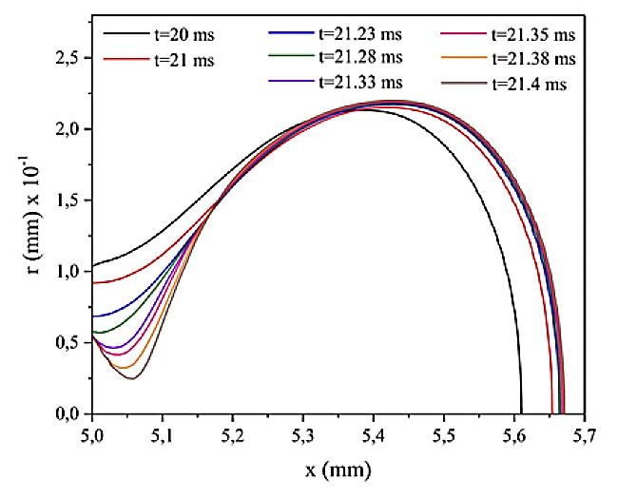
Figure 1: Figure caption (Times New Roman,9 pts, Centered)

    - About equations, key metrics, and nomenclature
Equations are centered and referenced by a number in brackets (1) placed at the right of the equation. Here is an example:

(1)

Use the international system of units (SI) and make sure the same symbol is used for the same quantity throughout the paper. All key metrics must be specified in the Nomenclature section including their symbols and measuring units (if dimensionless write -). Distinguish Latin symbols from Greek symbols, and if useful list subscripts (exponent or index), each list ordered alphabetically. The Nomenclature should be set in 2 columns for space saving where possible.
Acronyms should be avoided in the paper’s title unless they are of common use. Acronyms must be written in full length when first mentioned in the text.

    - About the references
References must be cited in the text by a number placed in square brackets [1] following the order of apparition in the text. The reference list will then be placed at the end of the paper. Use citation export functions of journals online to ensure proper citation. If the number of authors of a reference exceeds 6, then name the first 6 authors and then write “et al.”. See References section below for the format to be used.

    - About the paper quality and copyright
Eligible papers for JITH 2024 must be original and not previously published elsewhere. In addition to the scientific quality of the paper, it must be well written, to be positively evaluated during the peer-review.
The best contributions will be included in the JITH proceedings edited by Springer Nature as Book in the Series LNME. This publication is indexed Scopus, EI Compendex, INSPEC, SCImago, and is evaluated by Web of Science for the Conference Proceedings Citation Index (CPCI). See the previous JITH 2022 proceedings Book.
Authors must ensure they have the necessary permissions for using any material that might be protected by copyright.

- Conclusion (Times New Roman,12 pts, Bold
This section is mandatory. Remind concisely the objectives and major findings as well as the limitations of the work and possible perspectives or future research.

Nomenclature (Times New Roman, 10 pts, bold, 2 column)

Latin symbols
Symbol | Name | unit
C_{p} | specific heat | (J kg⁻¹ K⁻¹
k | thermal conductivity | W m⁻¹ K⁻¹
T | temperature | K
Nomenclature is written in Times New Roman, 9 pts.
Greek symbols
Symbol | Name | unit
α | thermal diffusivity | m² s⁻¹
ρ | volumetric mass density | kg m⁻³

Subscripts
Symbol | Name
a | air
ref | reference
s | surface

Acknowledgements (Times New Roman, 10 pts, Bold)
This section of Acknowledgements is optional. Any funding of the work should be acknowledged (scholarship, funded research project, sponsoring, etc.). Further thanks for any other support (scientific, technical, data & material, permission to publish, etc.) to persons and/or institutions might also be expressed here. (Times New Roman, 9 pts)

References (Times New Roman, 10 pts, Bold)
- Last Name First name initials, Last Name First name initials (Year) Paper title, Journal, Conference, etc., Volume, Pages. DOI. (Times New Roman, 9 pts)
- Last Name First name initials, Last Name First name initials (Year) Book title, edition, Publisher, Pages. ISBN.

Examples :
[1] Oke T R (2002) Boundary layer climates, second edition, Routledge, London, 464 pp. ISBN: 978-0415043199
[2] Luo J, Zou D, Wang Y, Wang S, Huang L (2022) Battery thermal management systems (BTMs) based on phase change material (PCM): A comprehensive review, Chemical Engineering Journal, Vol. 430, 132741, https://doi.org/10.1016/j.cej.2021.132741.

