Title of the paper
(Times New Roman, Bold,14 pts, Centered)
(Each paper is limited to 06 pages MAXIMUM, including Figures)

Authors: First name followed by the NAME (Times New Roman,11 pts, Centered),
Authors address (Times New Roman,10 pts, Centered)
Authors Email (Times New Roman,10 pts, Italics Centered)
(Email of the corresponding author in bold)

Abstract: The text of the abstract should be in Times New Roman, 10 pts, Justified, Single-spaced. The abstract should be a maximum of 10 lines. It should concisely reflect the objectives, methodology, results, and conclusions of the paper.

Keywords: 6 maximum.

Paragraph indentation: 1 cm. Margins: 2.5 cm Bottom, right and left. 3 cm top.

1. Title 1 (Times New Roman,12 pts, Bold)

1.1. Title 2 (Times New Roman,10 pts, Bold)

1.1.1. Title 3 (Times New Roman,10 pts, Italic)

The text must be written in Times New Roman, 10 pts, left and right justified and single-spaced.
The maximum number of pages is 6.
A paragraph starts with an indentation of 1 cm.
A paragraph and the following Title are separated by a line break.
References must be cited in the text by a number placed in square brackets [1]. This number corresponds to the order of appearance in the text. The reference list will then be placed at the end of the paper.

Equations are centered and referenced by a number in brackets (1) placed at the right of the equation.
Example :
(1)

Tables are inserted into the text and presented in the following format:
Above each table note the number and title of the table (Times New Roman,10 pts, Centered)

Table 1 : Title of the table
Centered | Symbol (Times New Roman,10 pts)  Units (Times New Roman,10 pts, Italics) | k  (W/m.K) | T  (°C)
Copper  Oak wood |  | 390  0,16 | 20  20

Figures appear in the appropriate place in the text.
Below each figure note the corresponding figure number and title (Times New Roman,10 pts, Centered).
All figures must be a uniform size (6 cm high by 8 cm wide) and centered. Two figures might be inserted side by side.
Figures and photographs should be in black and white rather than color.
CHECK THAT ALL FIGURES (including numbers and captions on the axes) ARE READABLE.

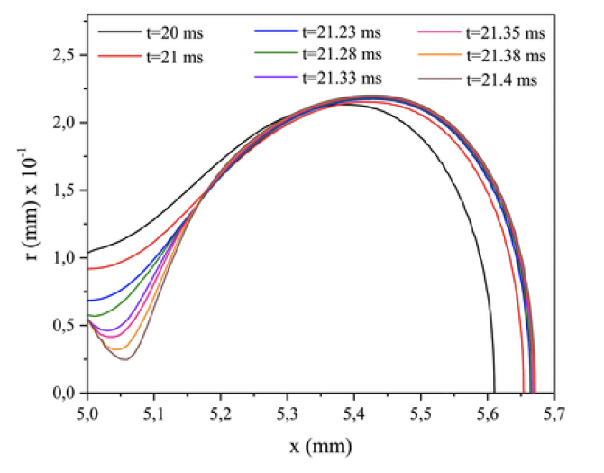
Figure 1 : Figure caption

Conclusion (Times New Roman,12 pts, Bold)

Nomenclature (Times New Roman,10 pts, Gras, 2 column)

Symbol Name, unit

k Thermal conductivity, W/m.K
T Temperature, K

Greek symbols
α Thermal diffusivity, m².s⁻¹

Exponent, Index
i internal

References (Times New Roman,10 pts, Bold)

[1] Authors (first name initial Name), Paper title, Journal (Conference…), Volume, Page, year.
Example
[2] J.J. Name et E. Name, Paper Title, Energy Conversion and Management, Volume 67, Pages 105-119, 2009.

